PRESS RELEASE ON OCCASION OF

18th INTERNATIONAL CHILDHOOD CANCER DAY – 15TH FEBRUARY 2019
By
CANKIDS …KIDSCAN
(National Society for Change for Childhood Cancer in India)

RAISE YOUR VOICE TOGETHER WITH CHILDREN WITH CANCER
NO MORE PAIN NO MORE LOSS

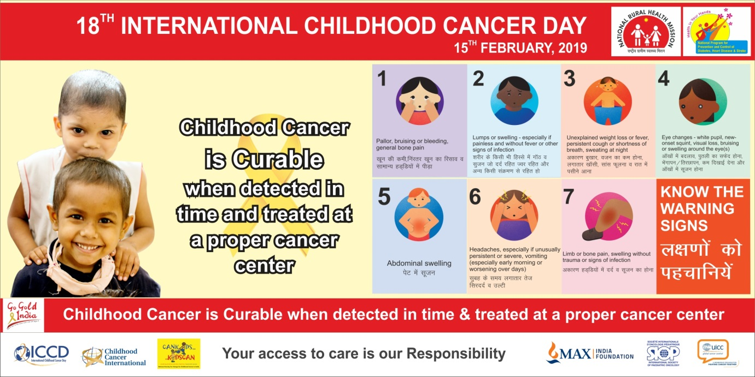
New Delhi; 15 February 2019

February 15th is celebrated worldwide as International Childhood Cancer Day – aimed at creating awareness and advocating for childhood cancer as much for honoring the bravery and courage of children fighting cancer in our State, country and worldwide.
Internationally Childhood Cancer Day is spearheaded by Childhood Cancer International – an umbrella organization of 188 parent, survivor and social support organizations like Cankids, in collaboration with SIOP (International Society of Pediatric Oncologists).
http://www.cankidsindia.org/iccd-2019.html)

International Childhood Cancer Day (ICCD) is celebrated around the world each year on February 15th. Originally commemorated in 2002, ICCD is a day founded by Childhood Cancer International (CCI), a global network of 188-member organizations in 96 countries. The global theme for ICCD 2018 is ‘No more Pain and No more Loss’ for children with cancer and their families.

On September 28, 2018 at the United Nations General Assembly, the World Health Organization (WHO) announced its new global initiative to address the disparity between childhood cancer survivals in low-middle versus high-income countries. Each year, more than 300,000 children ages birth to 19 years are diagnosed with cancer around the world. Approximately 8 in 10 of these children live in low and middle-income countries where their survival rate is often near 20%. This is in stark contrast to high-income countries, where cure rates exceed 80% for many common childhood cancers.
The Target Goal of the WHO Global Childhood Cancer Initiative is to eliminate all pain and suffering of children fighting cancer and achieve at least 60% survival for all children diagnosed with cancer around the world by 2030. This represents an approximate doubling of the current cure rate and will save an additional one million children’s lives over the next decade.

Cankids believes that making childhood cancer a national and global child health priority is a critical first step towards reducing premature child mortality 30 percent by 2030, and we can make a real impact and improve survival rates to compare with the developed countries, relatively easily and in a shorter period of time, the success of which will provide greater impetus to the war against cancer in the country.
It is necessary to advocate to policy makers that Childhood Cancer is Curable for which changes in state programs and policies should be made. # Say No To Pain is one such Advocacy Campaign which is led by Childhood Cancer Survivors, with 8 demands – for a clear childhood cancer control plan and policy, more and dedicated pediatric oncology cancer centers, better and qualified manpower and health professionals, affordable but quality treatment and drugs, focused interventions for specific childhood cancers that are highly curable like Hodgkins Lymphoma, Retinoblastoma (eye cancer) and Wilms Tumor (kidney cancer), acceptance of the age of childhood cancer up to 18 years of age, and family and civil society engagement.
The NGO celebrates ICCD each year across over 59 cancer centers in the country, where it partners with treating teams to enable best treatment, care and support for children with cancer and their families. We want to honor children with cancer and their families and help them fight this battle and assure them that “You Are Not Alone” and also aim to motivate children with cancer during the hard times of the treatment of cancer to help & support them.
This year Children with Cancer, families and Survivors will create ‘Golden Ring of Hope’ to mark the need of protection from pain. Children, their families and supporters will write messages/ signatures on ' Golden Ring of Hope’ and obtain pledges. The children undergoing treatment for cancer will also participate in Painting, Poetry and Slogan writing Competition on the theme “No More Pain No More Loss” through Creative Manch. There will be a competition of creative expression at every centre which will be judged by the jury and awarded accordingly.

TO know more and for ICCD information, awareness kit and graphics please log in to
http://www.cankidsindia.org/iccd-2019.html
CONTACT: Cankids Communications, Education, Public Awareness and Advocacy Department:
smcepaa@cankidsindia.org , info@cankidsindia.org , gmcepaa@cankidsindia.org
Chief Spokesperson: Poonam Bagai, Chairman Cankids 9811525745
CEPAA – Mukta Ojha – 8826975654 , Maan Vardhan Kanth – 9810127168

CHILDHOOD CANCER FACTSHEET
- Cancer incidence - developing countries not well known, because there has been fewer population-based cancer registries (PBCRs) with adequate completeness. (Source: NRCP - National Cancer Registry Program)
- Boys are around 20% more likely to develop cancer than girls but this male to female - This suggests a gender bias in diagnosing and registering cases in some developing countries. (Source: NRCP - National Cancer Registry Program)
- The reported incidence of childhood cancer in India in males is higher than in females in almost all population based cancer registries Gender bias in seeking healthcare, including treatment of cancer, is one possible explanation. (Source: NRCP - National Cancer Registry Program)
- 3 most common cancers in childhood comprise leukemia, brain tumors and lymphoma. (Source: IACR - International Agency for Research on Cancer)
- This improvement of survival reported from developed countries has resulted from increasing use of intensive chemotherapy combined with other modalities of treatment, improved generalised supportive management, application of results of clinical trials and centralisation of care permitting each patient to benefit from the best of the multidisciplinary expertise and technology available for these rare conditions. (Source: IACR - International Agency for Research on Cancer)
- The less favorable outcome in the developing countries can be attributed to late diagnosis, unavailability of treatment, therapy abandonment, prior undernourishment, inadequate supportive therapy and unsuccessful follow-up. All these factors relate to lack of financial resources to support efficient health care system for childhood cancer patients. (Source: NRCP - National Cancer Registry Program)
- The causes of majority of childhood cancers are unknown. (Source: IACR - International Agency for Research on Cancer
- Each year more than 3,00,000 (Age: 0-19yr) Children and adolescents are diagnosed with one of 16 forms of childhood cancer-cancers. (Source: IACR - International Agency for Research on Cancer)
- Out of the above mentioned numbers 40,000-50,000 (Age: 0-15yrs) are diagnosed in India. (Source: NRCP - National Cancer Registry Program) instead of this we can use 77800 (0-19 year) new cases each year in India.

CanKids…KidsCan, is a not-for-profit National Society, dedicated to a Change for Childhood Cancer in India. It enables best standards of treatment care and support for children with cancer and their families from moment fo diagnosis, through treatment and after. Presently Cankids is working in 51 cancer centers across the country providing holistic care and support to children with cancer and their families through its YANA – you are not an alone model, providing a range of 25 social support services, Care Centers and social support teams, through its Cankids Hospital Support Units. It partners with treating cancer centers, national and international organizations and State Governments to build capacities, promote quality care, research and impact and facilitate stakeholder engagement and patient, family and civil society engagement, thereby enabling best standards of treatment, care and support. Through its Go Gold India campaign it advocates for childhood cancer to be a child health priority in India

