PRESS RELEASE ON OCCASION OF

19th INTERNATIONAL CHILDHOOD CANCER DAY – 15TH FEBRUARY 2020
By
CANKIDS …KIDSCAN
(National Society for Change for Childhood Cancer in India)

RAISE YOUR VOICE for CHILDREN WITH CANCER
NO MORE BORDERS – India

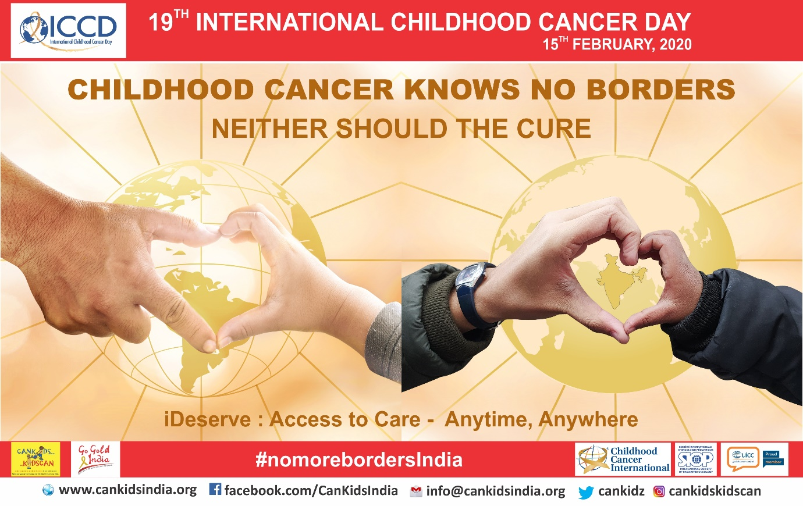

New Delhi: 12th February 2020

February 15th is celebrated worldwide as International Childhood Cancer Day – aimed at creating awareness and advocating for childhood cancer as much for honoring the bravery and courage of children fighting cancer in our State, country and worldwide.
The global theme for ICCD 2020 is ‘No More Borders’.
Cankids theme for ICCD 2020 is No More Borders – India! iDeserve: Access to Care – Anytime, Anywhere.
CanKids… KidsCan is a proud member of Childhood Cancer International (CCI), an international NGO and Non-State Actor in official relations with WHO. It is committed to WHO’s Global Initiative on Childhood Cancer. http://www.cankidsindia.org
80% of children with cancer live in low middle-income countries like India. They have less than a 20% childhood cancer survival rate. 20% of the children with cancer live in high income countries. They have more than an 80% childhood cancer survival rate.
WHO has launched a Global Initiative on Childhood Cancer - and a call out to MEMBER nations to ensure 60% survival rates in all LMICs.
In India - where survival rates are about 30-40%, where 65% children do not even make it to a cancer centre anywhere in the country - the Health Ministry has not included childhood cancer as a focus in the NPCDCS. Yet there are centres in India that have 80% and even higher survival rates, and others with 20% or lower survival rates.
Children with cancer in India deserve the best treatment care and support. They deserve equal access to care – Anytime! Anywhere!
"Mr Prime Minister - Why should where I am born decide whether I survive or not? " ask Childhood Cancer Survivors through a Haq Ki Baat campaign launched by Cankids Teenage and Young Adult Childhood Cancer Survivor group – Kidscan Konnect. We are: Sitara Khan from Delhi, Akriti Chauhan from Lucknow and Vikas Yadav from Mumbai
- Asking to meet the Prime Minister of India – Mr. Modi -why should where I am born decide whether I survive or not? https://www.youtube.com/watch?v=aO761jmq3lU&t=1s
- We are raising 300,000 pledges under iPLEDGE - 1 for each child who has cancer somewhere in the world each year - for Childhood Cancer to be a child and health priority in India. We will present these pledges of support to the PM when he meets us. https://www.cankidsindia.org/gogoldindia.html
- We are creating awareness around the country about Childhood Cancer and Access to Care - pinning gold ribbons, doing nukkad nataks, flashmobs, and awareness talks in schools, colleges rural and urban areas.
- We are also raising urgently needed funds for the holistic care of 200 children with cancer and their families provided by Cankids under its YANA you are not alone program pan India @ Rs 25000 per child per annum. Holistic Care includes medical support for drugs, diagnostics, therapies, prosthetics, treatment supportive care - nutrition, hygiene, infection control, blood support, Home away from Home, Education support, Emotional and Psychological Support, Child LIfe, Family Engagement, Patient Navigation, Information and Access, Survivorship and Palliative Care. https://fundraisers.giveindia.org/projects/childhood-cancer-knows-no-border-neither-should-its-cure

Cankids believes that making childhood cancer a national and global child health priority is a critical first step towards increasing survival rates to 60% by 2030.
“We can make a real impact and improve survival rates to compare with the developed countries, relatively easily and in a shorter period of time, the success of which will provide greater impetus to the War Against Cancer in the country.” says Poonam Bagai, Founder Chairman Cankids, herself a cancer survivor and patient Advocate.

International Childhood Cancer Day (ICCD) is celebrated around the world each year on February 15th. Originally commemorated in 2002, ICCD is a day founded by Childhood Cancer International (CCI), a global network of 171-member organizations in 88 countries. The global theme for ICCD 2020 is ‘No More Borders’ for children with cancer and their families.

On September 28, 2018 at the United Nations General Assembly, the World Health Organization (WHO) announced its new global initiative to address the disparity between childhood cancer survivals in low-middle versus high-income countries. Each year, more than 300,000 children ages birth to 19 years are diagnosed with cancer around the world. Approximately 8 in 10 of these children live in low and middle-income countries where their survival rate is often near 20%. This is in stark contrast to high-income countries, where cure rates exceed 80% for many common childhood cancers.
The Target Goal of the WHO Global Childhood Cancer Initiative is to eliminate all pain and suffering of children fighting cancer and achieve at least 60% survival for all children diagnosed with cancer around the world by 2030. This represents an approximate doubling of the current cure rate and will save an additional one million children’s lives over the next decade.

To commemorate International Childhood Cancer Day (ICCD), a day marked by WHO, CCI and other global partners to spotlight the challenges faced by children /adolescents with cancer and their families, our organization is hosting following list of activities at CHSU through which we aim to advocate theme of this year.
TO know more and for ICCD information, awareness kit and graphics please log in to:
https://www.cankidsindia.org/

Activities:  - National Childhood Cancer Competition - In each hospital artwork will be designed by children and a competition will be conducted on “iDeserve: Access to Care – Anytime. Anywhere.  - Hospitals will also get #nomorebordersindia cutout for national competition.  - The children will get a gift, a cushion with a kekadu cut out with message “Love Cures Cancer Give Kekadu a Hug”  - Outings – Hospitals support teams to organise airport/station/bridge visits in each cities. | Awareness:  - Information, Education & Communications material to create awareness about childhood cancer – in print, digital, social media, airports and metro rail cooperation.  - Exhibition –  “Haq Ki Baat”  iDeserve: Access to Care – Anytime, Anywhere  Exhibition and presentation of 3,00,000 pledges to Prime Minister Narendra Modi by the survivors in June 2020.  - #nomorebordersIndia Creative Manch – this March will be opened to all civil society and all social media platforms  - Change for Childhood Cancer in states - #nomorebordersIndia awareness campaigns with government departments
Advocacy:  - Advocate for “Haq Ki Baat” Pledge campaign - Go Gold India and collect 3,00,000 lac pledge  - Link: https://www.cankidsindia.org/gogoldindia.html  - Educate survivors and their families about their rights to demand for no more borders, i.e., every child has equal access to care anytime, anywhere | Fundraising:  - ICCD events throughout the months of January, February and March act as medium to request donors to sponsor and donate for the cause. Hence, we are hoping to receive maximum donations via this.  - Give India Fundraising Challenge - It helps in raising funds online for loved ones, charities and more  - Airports/ Metro Rail Corporations/ Malls: Reaching out all these public places in order to raise funds for kids who are suffering cancer

CONTACT: Cankids Communications, Education, Public Awareness and Advocacy Department (CEPAA):
managermktgcomm@cankidsindia.org amcepaa@cankidsindia.org info@cankidsindia.org ,
Chief Spokesperson: Poonam Bagai - Chairman Cankids - 9811525745
CEPAA – Shivangi Anand Bharti – 9910970233, Yashasvi Singh – 9561909337 and PayalTyagi – 7339503118

Survivors and leading the Haq Ki Baat Campaign: Sitara Khan – 7838567317 (Delhi), Akriti Chauhan (Lucknow) – 8174979585 and Vikas Yadav (Mumbai) - 7666389207

CHILDHOOD CANCER FACTSHEET
- Each year more than 3,00,000 (Age: 0-19yr) Children and adolescents are diagnosed with one of 16 forms of childhood cancer-cancers. (Source: IACR - International Agency for Research on Cancer – IICC -3 International Incidence on Childhood Cancer- 3 Report)
- India Incidence is 76800 (0-19 year) new cases each year in India. (Source: Cankids Quality Care Research and Impact (QCRI) Department
- Top 7 States leading Childhood Cancer Incidence accounting for 63% - Uttar Pradesh, Bihar, Maharashtra, West Bengal, Madhya Pradesh, Rajasthan and Andra Pradesh – in that order (Source: Cankids Quality Care Research and Impact (QCRI) Department)
- 65% or more children with cancer do not make it to a Cancer center anywhere in the country (Source: Extensive mapping by Cankids QCRI, NOP and MASSI departments of over 200 cancer centers in the country
- 3 most common cancers in childhood comprise leukemia, brain tumors and lymphoma. (Source: IACR - International Agency for Research on Cancer)
- This improvement of survival reported from developed countries has resulted from increasing use of intensive chemotherapy combined with other modalities of treatment, improved generalised supportive management, application of results of clinical trials and centralisation of care permitting each patient to benefit from the best of the multidisciplinary expertise and technology available for these rare conditions. (Source: IACR - International Agency for Research on Cancer)
- The less favorable outcome in the developing countries can be attributed to late diagnosis, unavailability of treatment, therapy abandonment, prior undernourishment, inadequate supportive therapy and unsuccessful follow-up. All these factors relate to lack of financial resources to support efficient health care system for childhood cancer patients. (Source: NRCP - National Cancer Registry Program)
- The causes of majority of childhood cancers are unknown. (Source: IACR - International Agency for Research on Cancer

CanKids…KidsCan, is a not-for-profit National Society, dedicated to a Change for Childhood Cancer in India. It enables best standards of treatment care and support for children with cancer and their families from moment fo diagnosis, through treatment and after. Presently Cankids is working in 51 cancer centers across the country providing holistic care and support to children with cancer and their families through its YANA – you are not an alone model, providing a range of 25 social support services, Care Centers and social support teams, through its Cankids Hospital Support Units. It partners with treating cancer centers, national and international organizations and State Governments to build capacities, promote quality care, research and impact and facilitate stakeholder engagement and patient, family and civil society engagement, thereby enabling best standards of treatment, care and support. Through its Go Gold India campaign it advocates for childhood cancer to be a child health priority in India

